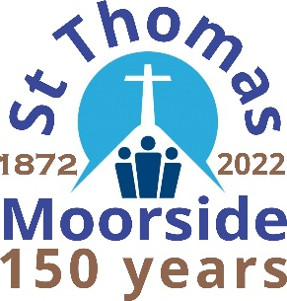
Songs of Praise
Sunday 22nd May
at
6.30pm

I’d like to sing:

Songs of Praise
Sunday 22nd May
at
6.30pm

I’d like to sing:

Songs of Praise
Sunday 22nd May
at
6.30pm

I’d like to sing:

Songs of Praise
Sunday 22nd May
at
6.30pm

I’d like to sing:

Songs of Praise
Sunday 22nd May
at
6.30pm

I’d like to sing:

